Assignment 6
Bash Environment & Workspace Set up
Olajide Kuti
Group 1
Task 1
Screenshot 1
Screenshot 2
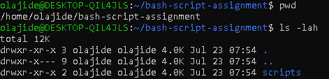
Notes for Task 1

1. What is Bash?
Bash (Bourne Again SHell) is a Unix shell and command-line interpreter that allows users to interact with the operating system. It can execute commands interactively and automate repetitive tasks through shell scripts.

2. What is the difference between Shell and Bash?

A shell is a command-line interface that allows users to communicate with the operating system. Bash is one implementation of a shell. In other words, Bash is a specific shell that provides additional features such as scripting, command history, tab completion, arrays, functions, and improved scripting capabilities.

3. Why is it important to confirm the Bash version before writing scripts?

Confirming the Bash version ensures that the required features used in a script are supported by the installed version. Different Bash versions may introduce new functionality or syntax, so verifying the version helps avoid compatibility issues when running scripts on different Linux systems

Task 2 – First Bash Script

Screenshot 1

Screenshot 2
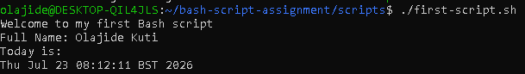

Screenshot 3
Task 3 – Variables: user information scripts
Screenshots 1
Screenshot 2

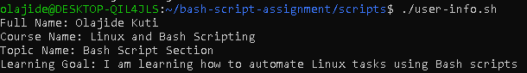

Note for task 3

What is a variable in Bash?
A variable in Bash is a named storage location used to hold data such as text, numbers, or command output. Variables make scripts more flexible and reusable because values can be stored once and referenced multiple times.

2. Why should we avoid spaces around the = sign when creating variables?
Bash requires variable assignments to have no spaces around the = sign. Adding spaces causes Bash to interpret the statement incorrectly, which results in an error.
Task 4 – Arrays & Loops: Tools Checklist Scripts
Screenshot 1
Screenshot 2

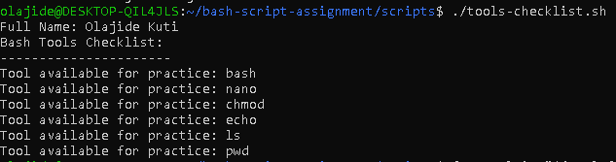
What is an array in Bash?
An array in Bash is a variable that stores multiple values under a single name. Each value is stored at a different index, making it easy to manage related data.

Why are arrays useful in scripts?
Arrays allow multiple related values to be stored and processed together, reducing repetition and making scripts easier to maintain.

What does "${tools[@]}" mean?
"${tools[@]}" expands to every element in the tools array, allowing a loop to process each item one by one.

What is the purpose of the for loop in this script?
The for loop iterates through each element of the tools array and performs the same action—printing each tool—without repeating code.

Task 5 – Loops: Number Counter Script
Screenshot 1
Screenshot 2
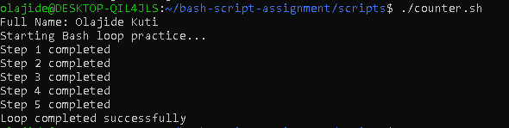

What is a loop?
A loop is a programming construct that repeatedly executes a block of code until a specified condition is met or until all items in a collection have been processed. In Bash, loops help automate repetitive tasks.

2. Why do we use loops in Bash scripting?
Loops are used to automate repetitive operations without writing the same code multiple times. They make scripts more efficient, easier to maintain, and reduce the likelihood of errors.

3. How many times did the loop run in your script?

The loop ran five times, once for each value from 1 to 5.

Task 6 – Files and Conditionals (File Validation Scripts)

Screenshot 1
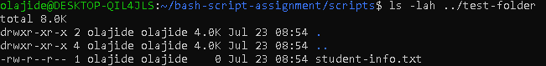
Screenshot 2
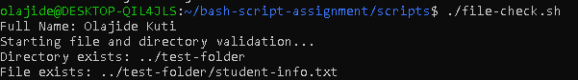

1. What does -d check in Bash?
The -d test checks whether a specified path exists and is a directory. It returns true if the directory exists and false otherwise.

2. What does -f check in Bash?
The -f test checks whether a specified path exists and is a regular file. It returns true if the file exists and false otherwise.

3. Why should file and directory paths be stored in variables?
Storing file and directory paths in variables makes scripts easier to maintain, improves readability, and allows paths to be updated in one place without modifying multiple lines of code.

4. What happens if the file does not exist?
If the file does not exist, the -f condition evaluates to false, and the script executes the else block, displaying a message indicating that the file was not found. This helps prevent errors by allowing the script to handle missing files gracefully.
File and directory checks are used extensively in production Bash scripts. For example, a deployment script may verify that a configuration file exists before restarting a service, or a backup script may confirm that the destination directory is available before copying files. These checks improve reliability and help prevent automation failures.
Task 7 – Conditionals- Pass or Retry Scripts
Screenshot 1 & 2
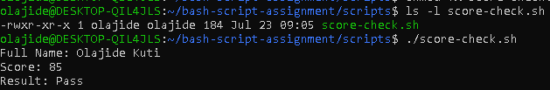
Screenshot 3 & 4
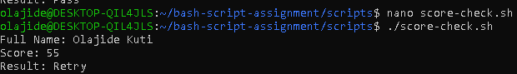

1. What is the purpose of if-else in Bash?
The if-else statement allows a Bash script to make decisions by executing different blocks of code depending on whether a specified condition evaluates to true or false.

2. What does -ge mean?
The -ge operator means greater than or equal to. It is used to compare numeric values in Bash.
Example:
if [ "$score" -ge 70 ]
This checks whether the score is 70 or higher.

3. Why should conditions be tested with different values?
Testing conditions with different values ensures that both the if and else branches work correctly. It helps verify that the script behaves as expected under different scenarios.

4. How can conditionals help in automation scripts?
Conditionals enable automation scripts to make intelligent decisions based on system state or input. For example, they can check whether a service is running, whether a file exists, or whether a command succeeded before performing the next action.
if-else statements are used extensively in production automation. For example:
- Restart a service only if it has stopped.
- Create a backup only if the destination directory exists.
- Send an alert only if disk usage exceeds a threshold.
- Deploy an application only if all prerequisite checks pass.
These decision-making capabilities are fundamental to reliable automation.

Task 8 – Functions: Final Bash Automations Scripts

3 screenshots combined
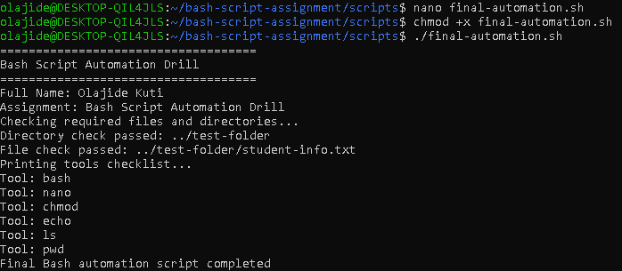
What is a function in Bash?
A function in Bash is a reusable block of code that performs a specific task. Functions allow related commands to be grouped together and executed whenever needed, making scripts more organized and easier to maintain.

2. Why are functions useful in scripts?
Functions reduce code duplication, improve readability, simplify maintenance, and make scripts modular. They allow the same logic to be reused without rewriting code.

3. Which functions did you create in this script?
The script contains the following functions:
- print_header()
- print_user_details()
- check_files()
- print_tools()
Each function performs a specific responsibility, making the script easier to understand and extend.

4. How does this final script combine variables, arrays, loops, conditionals, files, and functions?
The script combines multiple Bash concepts into one automation workflow. Variables store reusable values such as the user's name and file paths. An array stores the list of Bash tools. A for loop iterates through the array to display each tool. Conditional statements (if-else) verify whether the required directory and file exist. Functions group related tasks into reusable sections, improving readability and maintainability. Together, these concepts demonstrate how Bash can be used to build structured automation scripts.

